
PROJECT TITLE
Disaster Healthcare Resource Allocation using Greedy Algorithms
A CAPSTONE PROJECT REPORT
A Capstone Project Report submitted in partial fulfilment of the requirements for the course
CSA-0603 Design And Analysis Of Algorithms
to the award of the degree of
BACHELOR OF TECHNOLOGY IN CSE/ARTIFICIAL INTELLIGENCE & DATA SCIENCE
Submitted by
K.Sravan Kumar (192311210)
Under the Supervision of
Dr. P. Solainayagi
SIMATS ENGINEERING
Saveetha Institute of Medical and Technical Sciences
Chennai – 602105
SEPTEMBER 2026
SIMATS ENGINEERING
Saveetha Institute of Medical and Technical Sciences
Chennai-602105
BONAFIDE CERTIFICATE
This is to certify that the Capstone Project entitled "Disaster Healthcare Resource Allocation using Greedy Algorithms" has been carried out by K.Sravan Kumar (192311210) under the supervision of Dr. P. Solainayagi and is submitted in partial fulfilment of the requirements for the current semester of the B.Tech CSE/AIDS program at Saveetha Institute of Medical and Technical Sciences, Chennai.
COURSE COORDINATOR  Dr .F. Mary Harlin Fernandez  Professor  Department Of CSE  SIMATS Engineering  Chennai – 602105. | COURSE FACULTY  Dr. P. Solainayagi  Professor  Department Of CSE  SIMATS Engineering  Chennai – 602105.

SIMATS ENGINEERING
Saveetha Institute of Medical and Technical Sciences
Chennai-602105
DECLARATION
I, K.Sravan Kumar, of the Department of CSE/AIDS, SIMATS Engineering, Saveetha Institute of Medical and Technical Sciences, Chennai, hereby declare that the Capstone Project Work entitled "Disaster Healthcare Resource Allocation using Greedy Algorithms" is the result of my own bonafide effort. The work presented herein is original and has been carried out in accordance with engineering ethics and academic integrity. All sources, references, data, software resources, datasets, and AI-assisted resources used in the project have been appropriately acknowledged. The data, results, analysis, and findings have not been fabricated, falsified, or manipulated.
Place: Chennai
Date: September 2026
Signature of the Student with Name
K.Sravan Kumar
INDIVIDUAL CONTRIBUTION STATEMENT

Student / Reg. No. | Responsibilities | Design & Development | Testing & Analysis | Report Contribution | %
K.Sravan Kumar / 192311210 | System architecture, greedy optimization engine, frontend and integration | UI, architecture, algorithm implementation, integration | System testing, algorithm validation | All chapters, diagrams, appendices | 50%

ABSTRACT
Disasters such as cyclones, floods and earthquakes create a sudden surge in casualties across multiple affected zones while healthcare resources such as ambulances, medical kits, blood units and hospital beds remain severely limited. Coordinators must decide, often within minutes, which zone receives which resource so that the greatest number of lives can be protected without exceeding the available resource pool. This project proposes a web-based Disaster Healthcare Resource Allocation system that applies Design and Analysis of Algorithms (DAA) techniques to this problem. The core optimization engine uses a Greedy Algorithm that ranks affected zones by a severity-to-resource-cost ratio and allocates ambulances, medical kits and hospital beds to the highest-priority zones first until the resource pool is exhausted. A Priority Queue (binary max-heap) manages live casualty triage so that critical cases are always served ahead of stable ones, and Dijkstra's shortest-path algorithm — itself a greedy technique — computes the fastest ambulance route from each incident zone to the nearest hospital with available capacity. The application manages zones, hospitals, resources, casualty reports and dispatch history through a responsive interface, and produces zone-wise allocation plans, dispatch routes, remaining-resource summaries and response-time analytics. Testing is performed using controlled disaster-simulation datasets covering multiple concurrent incident zones. The expected outcome is a transparent, repeatable decision-support system that reduces manual coordination effort and demonstrates how classical greedy optimization techniques apply to a real-world, time-critical humanitarian problem.
Keywords: Disaster Response, Healthcare Resource Allocation, Greedy Algorithm, Priority Queue, Dijkstra's Algorithm, DAA, Triage, Resource Optimization, Web Application

TABLE OF CONTENTS
Sl. No. | Title | Page No.
i | Certificate from the Supervisor | ii
ii | Declaration by the Candidate | iii
iii | Individual Contribution Statement | iv
iv | Abstract | v
v | List of Figures | vi
vi | List of Tables | vii
vii | List of Abbreviations / Symbols | viii
1 | Chapter 1: Introduction and Engineering Problem | 9-10
2 | Chapter 2: Literature Review and Existing Solutions | 11-12
3 | Chapter 3: Engineering Design & Trade-offs, Sustainability, Ethics, Safety, Risk & Security | 13-18
4 | Chapter 4: Implementation, Testing & Results, Project Management | 19-26
5 | Chapter 5: Conclusion, Future Work and Reflection | 27-28
 | References | 29
 | Appendices | 30-32

LIST OF FIGURES
Figure No. | Figure Name | Page No.
3.1 | Disaster Healthcare Resource Allocation Architecture | 16
3.2 | Greedy-Based Resource Allocation Flow | 17
3.3 | Triage Priority-Queue Processing Flow | 17
3.4 | Greedy Ambulance Routing Flow (Dijkstra's Algorithm) | 18
4.1 | Response Command Center (Login / Landing) | 20
4.2 | Live Triage and Priority-Queue Dispatch | 23
4.3 | Optimized Resource Allocation Report | 24
4.4 | Analytics Dashboard | 25

LIST OF TABLES
Table No. | Table Name | Page No.
2.1 | Review of Existing Work | 11
2.2 | Comparative Analysis | 12
3.1 | Stakeholder / User Requirements | 13
3.2 | Functional and Non-Functional Requirements | 14
3.3 | Constraints and Applicable Standards | 14
3.4 | Design Specifications | 15
3.5 | Alternative Solution Evaluation | 16
3.6 | Trade-off Analysis | 18
3.7 | Sustainability, Ethics, Safety and Security | 18
3.8 | Risk Register | 18
4.1 | Software and Development Resources | 19
4.2 | Test Plan | 21
4.3 | Verification Results | 22
4.4 | Objective Achievement | 26
4.5 | Project Roles and Milestones | 26
4.6 | Project Cost Estimate | 26

LIST OF ABBREVIATIONS / SYMBOLS
Symbol | Description | Meaning
DAA | Design and Analysis of Algorithms | Algorithm design and complexity analysis
DHRA | Disaster Healthcare Resource Allocation | Project system name
DP | Dynamic Programming | Optimization technique
API | Application Programming Interface | Software communication interface
UI | User Interface | Application interaction layer
DB | Database | Persistent relational storage
ETA | Estimated Time of Arrival | Predicted ambulance arrival time
MCI | Mass Casualty Incident | Large-scale casualty event

CHAPTER 1

INTRODUCTION AND ENGINEERING PROBLEM

1.1 Background
A disaster response operation is a constrained decision-making process in which coordinators must direct limited healthcare resources — ambulances, medical kits, blood units, field hospital beds and medical staff — across several affected zones that differ in casualty severity, population density and accessibility. Deciding manually which zone should receive which resource becomes difficult once the number of incident reports grows and every additional minute of delay can cost lives. An algorithmic system can model resource allocation as a constrained optimization problem and recommend a high-impact allocation plan while respecting the available resource pool.

1.2 Need for the Project
➢ Manual resource allocation is slow and error-prone when many incident zones report casualties simultaneously.
➢ Coordinators must balance casualty severity, resource cost and response time simultaneously under extreme time pressure.
➢ A large number of affected zones and hospitals creates many possible allocation combinations that are difficult to compare manually.
➢ Field teams and hospital administrators need quick, shared access to resource availability and triage status.
➢ Greedy optimization provides fast, systematic and repeatable allocation decisions suited to time-critical situations.
➢ The project combines a responsive web interface, Flask backend, MySQL database and a DAA-based greedy optimization engine.

1.3 Problem Statement
Disaster healthcare resource allocation is difficult because multiple affected zones report different casualty severities and resource requirements at the same time, while responders must work within a fixed pool of ambulances, medical kits and hospital beds. The engineering problem is to design and implement a system that manages live disaster-response activity and uses a greedy optimization algorithm to allocate healthcare resources to the highest-priority zones first, maximizing the number of casualties served without exceeding the available resource pool or response-time constraints.

1.4 Project Aim
To design and implement a reliable web-based Disaster Healthcare Resource Allocation system that uses a Greedy Algorithm, a Priority Queue for triage and Dijkstra's shortest-path algorithm for routing, to recommend a high-impact, budget-aware resource allocation plan across multiple affected zones.

1.5 Project Objectives
➢ To design a web-based disaster-response management system with a structured database and clear user roles.
➢ To implement casualty intake, severity scoring and priority-based triage ranking.
➢ To implement secure zone, hospital, resource and dispatch data management.
➢ To validate resource requests, prevent over-allocation and maintain consistent resource-pool and zone information.
➢ To generate optimized allocation plans, ambulance routing recommendations, dispatch history and analytics reports.
➢ To test the greedy allocation and routing operations using controlled disaster-simulation datasets and multiple concurrent incident scenarios.

1.6 Scope
➢ Includes zone ID, location, casualty count, severity score, resource requirement and hospital capacity data.
➢ Includes Casualty & Triage Management, Resource & Hospital Management, Greedy Allocation Optimization and Dashboard & Analytics.
➢ Uses MySQL for normalized persistent storage of users, zones, hospitals, resources, casualty reports and dispatch records.
➢ Large-scale multi-agency deployment, live GPS feeds from real ambulances and government emergency-service integration are outside the academic prototype scope.
➢ Assumes valid incident data, authenticated users and configured resource and triage rules.

1.7 Expected Engineering Outcome
The intended outcome is a working prototype that demonstrates DAA-based greedy optimization through a real-time disaster-response interface, valid resource-pool-aware allocation recommendations, priority-queue-driven triage, shortest-path ambulance routing, dispatch analytics and functional validation.

CHAPTER 2

LITERATURE REVIEW AND EXISTING SOLUTIONS

2.1 Review Method
The review was organized around recent work in disaster logistics, emergency-resource allocation, hospital-capacity management, greedy and heuristic optimization, and ambulance-routing strategy. These studies provide methods for prioritizing casualties, allocating scarce medical resources and routing emergency vehicles under time pressure.

2.2 Review of Existing Work
Table 2.1 – Review of Existing Work
Author & Year | Title / Study | Methodology | Advantages | Disadvantages
Sheu (2007) | Emergency Logistics Distribution Approach for Quick Response | Fuzzy clustering and multi-objective optimization | Handles uncertain demand under disaster conditions | Higher modelling and computational complexity
Rawls & Turnquist (2010) | Pre-positioning of Emergency Supplies for Disaster Response | Stochastic optimization model | Accounts for demand and network uncertainty | Requires extensive historical/probabilistic data
Wex et al. (2014) | Emergency Response in Natural Disaster Management: Allocation and Scheduling of Rescue Units | Heuristic and metaheuristic scheduling | Balances multiple rescue-unit objectives | Computationally intensive for large instances
Anaya-Arenas et al. (2014) | Relief Distribution Networks: A Systematic Review | Literature-based network review | Broad view of distribution strategies | Focuses on review rather than a deployable system
Ahmadi et al. (2015) | A Multi-Depot Vehicle Routing Model for Post-Disaster Relief | Vehicle routing with heuristic solvers | Improves delivery route efficiency | Sensitive to network size and depot placement

2.3 Comparative Analysis
Table 2.2 – Comparative Analysis
Existing Approach | Advantages | Limitations | Relevance
Manual coordination | Flexible human judgement | Slow and error-prone during mass-casualty events | Motivates algorithmic assistance
Spreadsheet-based tracking | Easy filtering and comparison | Limited optimization and no real-time interaction | Useful baseline
Rule-based dispatch | Fast and simple | May miss higher-impact allocation combinations | Baseline heuristic
Optimization-based system | Systematic, constraint-aware allocation | Requires a clear objective and constraint model | Directly supports project

2.4 Research / Engineering Gap
The project addresses a practical gap by integrating live casualty triage, hospital-capacity tracking, resource-pool management and greedy allocation optimization in a single web application. Existing approaches often model resource pre-positioning, routing or scheduling separately, while this project connects severity-based triage, resource allocation and shortest-path dispatch in one coordinated decision-support tool.

2.5 Proposed Contribution
The proposed system connects casualty reports, hospital and resource data, live triage and DAA-based greedy optimization in one platform. The optimization objective, ranking criteria and constraints are made visible so that allocation recommendations can be explained, tested and compared against manual decisions.

CHAPTER 3

ENGINEERING DESIGN & TRADE-OFFS, SUSTAINABILITY,

ETHICS, SAFETY, RISK & SECURITY

3.1 Requirements

Stakeholder | Requirement
Disaster Response Coordinator | Manage zones, resources, run the allocation engine and review dispatch reports.
Hospital Administrator | Update bed, staff and equipment capacity; accept incoming casualties.
Field Medical Team | Submit casualty and severity reports; view assigned resources and routes.
Analyst | View coverage, response-time and resource-utilization analytics.
Project Evaluator | Verify DAA algorithms, complexity, constraints and testing evidence.
System | Maintain consistent resource-pool, triage and dispatch data.

Requirement | Type | Measurable Target
Casualty & triage intake | Functional | Add/update casualty records with severity score
Resource & hospital management | Functional | Add/update/delete resource and hospital records
Greedy allocation | Functional | Return a feasible high-priority allocation plan
Resource-pool control | Functional | Never exceed the available resource pool
Ambulance routing | Functional | Return shortest available route to a hospital with capacity
Search and sorting | Functional | Return relevant zone/resource results ranked by priority
Usability | Non-Functional | Clear navigation and feedback under time pressure
Security | Non-Functional | Authenticated role-based access

Standard / Code | Requirement | Application
ISO/IEC 25010 | Software quality characteristics | Usability, reliability, maintainability and performance
ISO/IEC/IEEE 29148 | Requirements engineering practices | Functional and non-functional requirements
ISO 22320 | Emergency management — Requirements for incident response | Structure of the incident/response workflow
REST API design principles | Communication between frontend and Flask backend | API layer design
Academic integrity | Acknowledge sources and tools | References, dataset and AI-assisted resources disclosed

3.3 Design Specifications

Parameter | Target / Requirement | Unit | Priority
Resource Pool | Configurable total resource budget | ₹ Cr equiv. | High
Resource Cost | Cost per ambulance / kit / bed unit | ₹ Lakh | High
Severity Score | Normalized casualty severity | Score (0–100) | High
Zone Count | Configured maximum concurrent zones | Zones | High
Resource Type | Ambulance / Medical Kit / Bed / Blood Unit | Category | High
Response Time | Maximum acceptable dispatch ETA | Minutes | Medium
Optimization | Maximize severity coverage within resource pool | Objective | High

3.4 Alternative Solutions & Evaluation
Alternative 1: Manual coordination via radio and spreadsheets. Simple and infrastructure-free, but comparison across many zones becomes slow and inconsistent under pressure.
Alternative 2: Exhaustive/DP-based optimal allocation (0/1 Knapsack style). Guarantees an exact optimum for a defined discretized resource model, but is slower and harder to re-run every time new casualty reports arrive.
Alternative 3: Proposed Greedy-based web system. Ranks zones by a severity-to-cost ratio and allocates resources iteratively; very fast to compute and re-compute, directly demonstrates greedy-choice and priority-queue DAA concepts, and is well suited to the rapidly changing nature of a live disaster response.

Criterion | Weight | Manual | DP / Exhaustive | Proposed (Greedy)
Allocation quality | 25% | Medium | High | Medium-High
Resource-pool handling | 20% | Low | High | High
Speed / re-computation | 20% | Medium | Low | High
Constraint handling | 20% | Low | Medium | High
DAA relevance | 15% | Low | Medium | High
Overall suitability | 100% | Medium-Low | Medium | High

3.5 Selected Design & Detailed Design
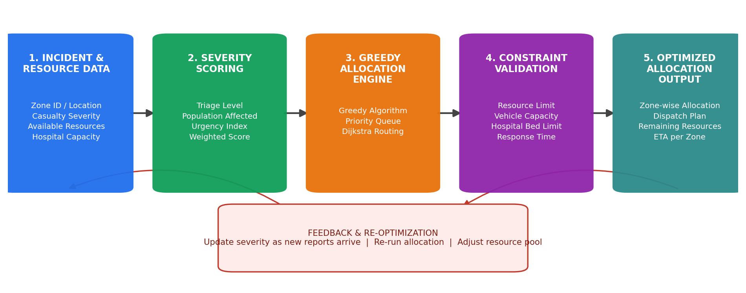
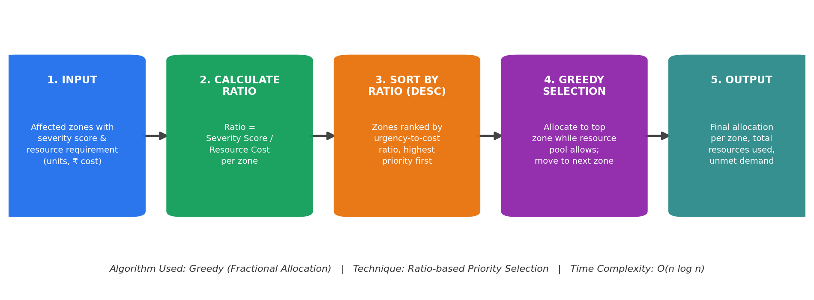
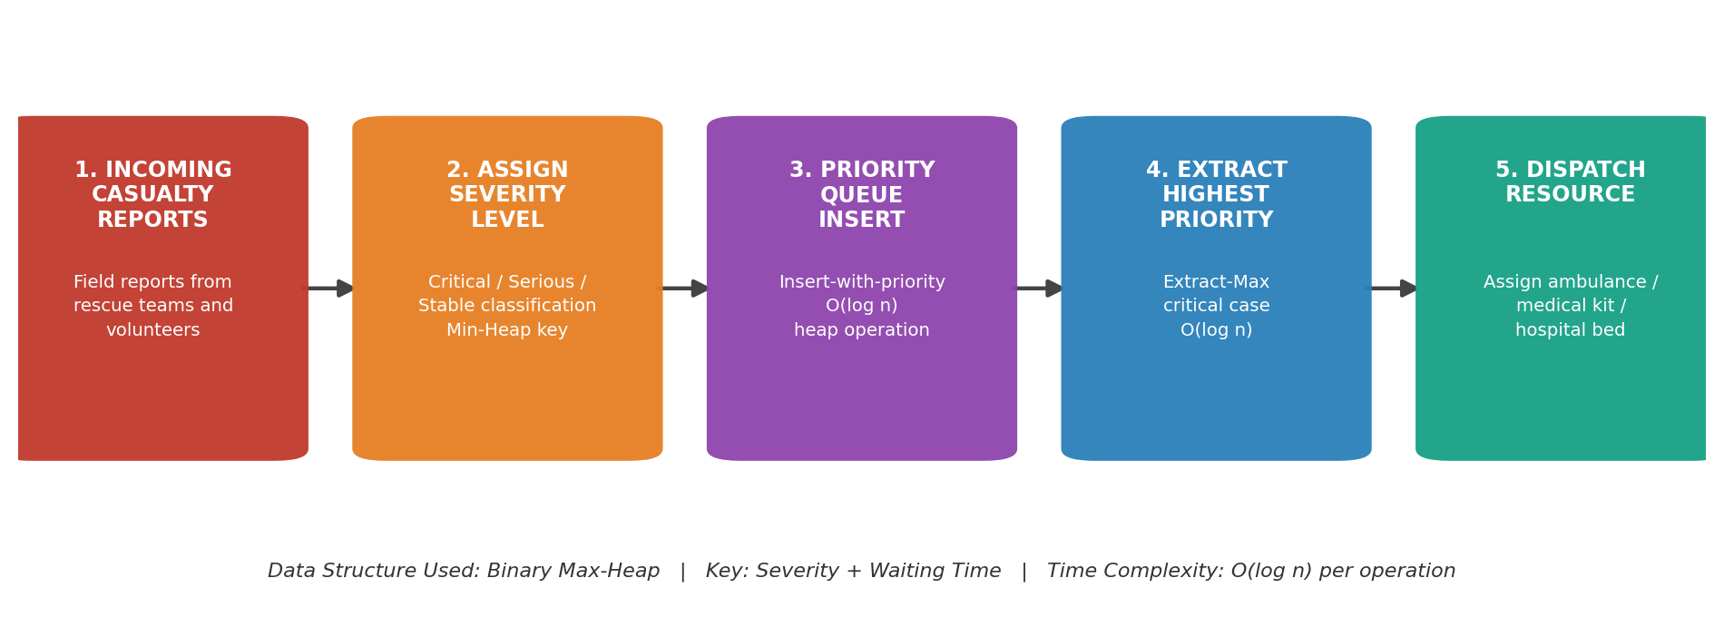
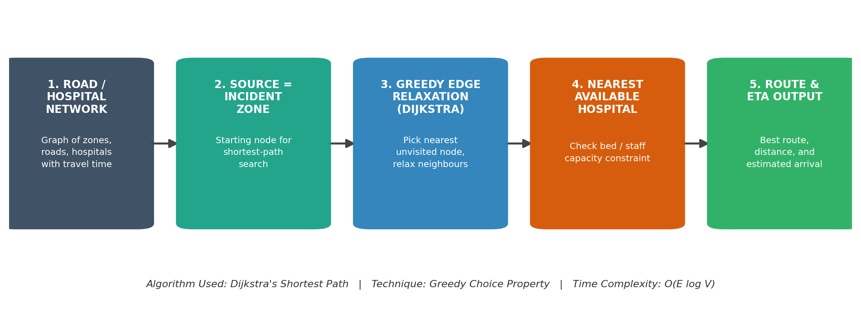
The web-based layered design is selected because it supports real-time interaction while making the DAA concepts (greedy selection, priority queue, shortest-path) visible. The architecture separates the interface, backend services, triage processing, optimization engine, database and analytics.
Layer | Main Responsibility
User / Web Interface | Authentication, dashboards, triage screens and reports.
Flask API Layer | Routes requests, validates input and manages sessions.
Triage Service | Processes casualty reports, assigns severity and manages the priority queue.
Optimization Engine | Runs the Greedy allocation algorithm and Dijkstra routing.
Constraint Validation | Checks resource pool, response-time and hospital-capacity limits.
MySQL Database | Stores users, zones, hospitals, resources, casualties and dispatch records.
Analytics Layer | Generates coverage, response-time and utilization insights.

3.6 Trade-off Analysis

Design Decision | Alternative | Benefit | Disadvantage | Final Decision
Greedy Allocation | 0/1 Knapsack (DP) | Fast, easily re-run as new reports arrive | Not always the global optimum | Selected
Priority Queue (Max-Heap) | Linear re-scan of list | O(log n) insert/extract vs O(n) scan | Slightly more complex to implement | Selected
Dijkstra Routing | Static pre-computed routes | Adapts to blocked/changed roads | Higher per-query cost than lookup | Selected
MySQL | Flat files | Structured queries and persistence | Requires DB setup | Selected

3.7 Sustainability, Ethics, Safety, Risk & Security

Domain | Consideration | Evidence | Impact
Sustainability | Use efficient software resources | Software-only prototype | Low infrastructure requirement
Ethics | Use responsible casualty data | Acknowledged/public or synthetic simulation data | Reduces data-privacy concerns
Safety | Never suggest an allocation that exceeds capacity | Server-side constraint validation | Prevents unsafe over-commitment of resources
Security | Protect users and casualty data | Hashing, sessions, role-based access | Improved protection of sensitive incident data
Data Integrity | Prevent invalid or duplicate dispatch transactions | Server-side validation and atomic updates | Consistent results across concurrent users

Risk | Likelihood | Severity | Level | Mitigation | Residual
Over-allocation beyond resource pool | Medium | High | High | Server-side pool and constraint validation | Low
Stale or delayed severity data | Medium | High | High | Live triage updates and re-optimization | Low-Medium
Incorrect greedy ranking | Medium | High | High | Known test cases and constraint checks | Low-Medium
Unauthorized access to incident data | Low-Medium | High | High | Authentication and role authorization | Low

CHAPTER 4

IMPLEMENTATION, TESTING & RESULTS, PROJECT MANAGEMENT

4.1 Development Approach & Resources
The project follows an incremental development approach. Requirements and resource-allocation constraints are defined first, followed by database design and interface implementation. Triage and dispatch operations are then integrated with the greedy optimization engine, followed by algorithm testing, system testing and analytics validation.

Resource | Purpose
HTML / CSS / JavaScript | Responsive user interface
Bootstrap 5 | UI components and responsive layout
Python Flask | Backend and REST APIs
MySQL | Persistent relational storage
Chart.js | Analytics visualization
VS Code | Development and debugging

4.2 Software Implementation & Modern Tools Used
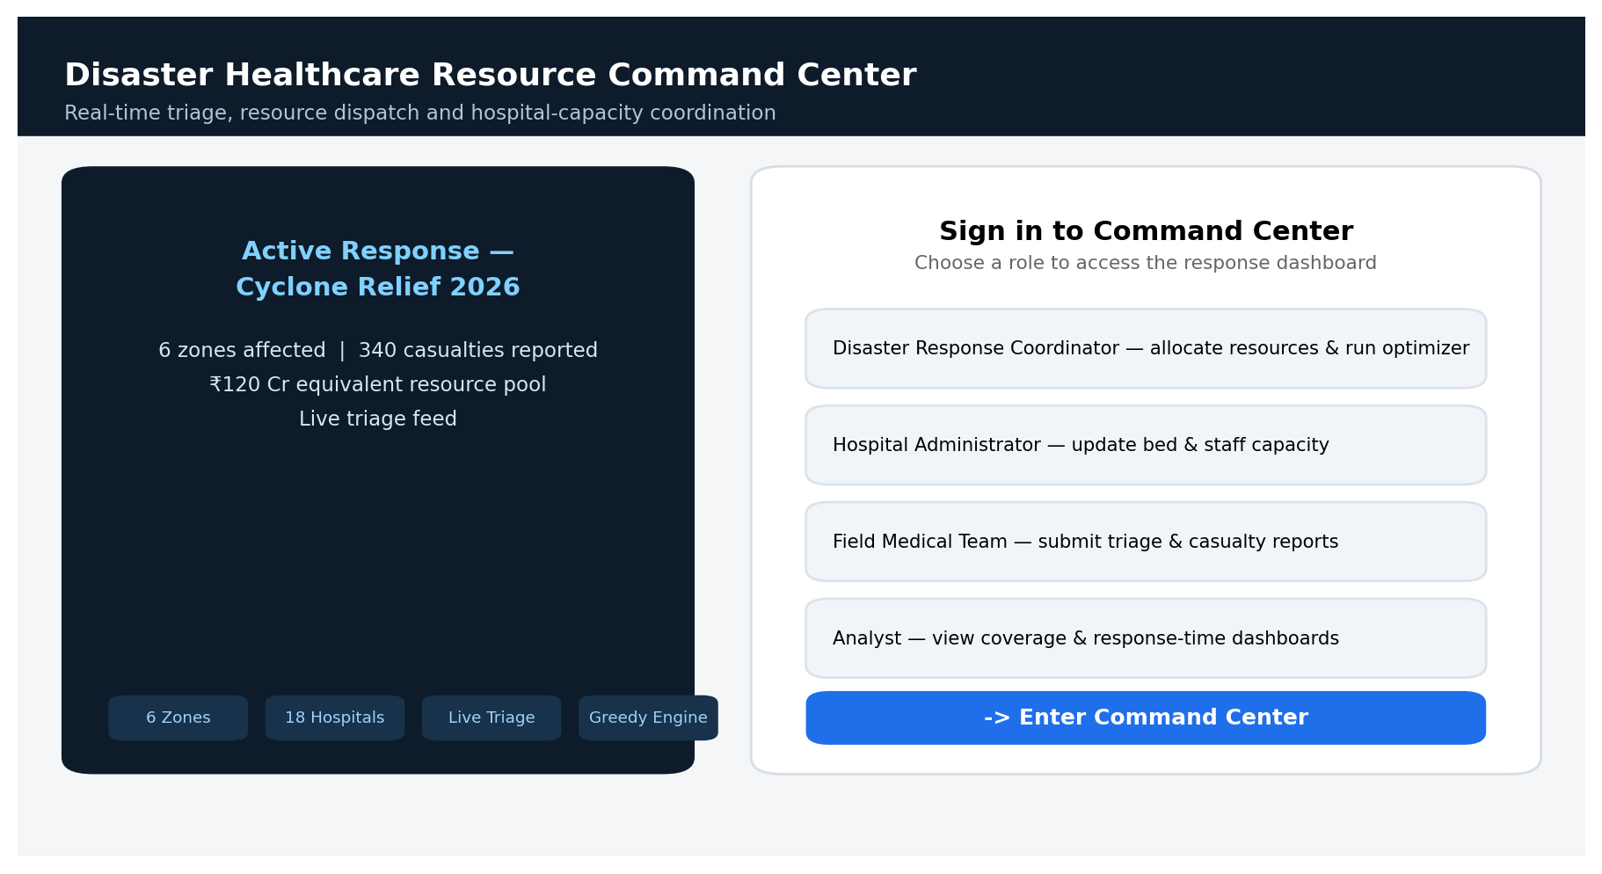

Tool / Software | Purpose | Stage
Python Flask | Backend and REST API | Implementation
MySQL | Database management | Design/Implementation
Bootstrap 5 | Responsive UI | Frontend
Chart.js | Analytics charts | Frontend/Analytics
Greedy Optimization Engine | Resource allocation | DAA Implementation
VS Code | Coding and debugging | All stages

4.2.1 Data Model and File Format
Each zone record contains ZoneID, Location, CasualtyCount, SeverityScore, ResourceRequirement and accessibility indicators such as distance to nearest hospital and road condition. Each resource record contains ResourceID, Type, UnitCost and AvailableQuantity. These values are used to derive a severity-to-cost ratio for greedy optimization.
Example: Z01 | Riverside Colony | Casualties 340 | Severity 92 | Ambulances Needed 8 | Medical Kits Needed 40 | Distance to Hospital 6.4 km

4.2.2 Module Implementation
Module | Input | Processing | Output
Casualty & Triage Management | Casualty and severity reports | Store, validate and rank by priority queue | Ranked triage list
Resource & Hospital Management | Resource, hospital and capacity data | Validate updates and track availability | Resource and capacity status
Allocation Optimization | Zones, costs, severity, constraints | Run Greedy allocation and Dijkstra routing | Optimized allocation and route plan

Module 3: Resource Allocation & Routing Optimization Module
This module is the main DAA component of the project. It allocates available healthcare resources to the affected zones based on casualty severity, resource cost, the available resource pool and squad-style constraints, then computes the fastest ambulance route to a hospital with capacity. The module uses a Greedy Algorithm together with a Priority Queue and Dijkstra's shortest-path algorithm to maximize the number of high-severity casualties served within the resource pool.

Features
➢ Zone Prioritization: Ranks affected zones by severity-to-cost ratio.
➢ Resource-Pool Optimization: Ensures the selected allocation stays within the available resource budget.
➢ Greedy Allocation Algorithm: Iteratively allocates resources to the highest-priority zone first.
➢ Priority Queue Triage: Maintains a live max-heap of casualty cases ordered by severity and waiting time.
➢ Dijkstra Routing: Computes the shortest available route from an incident zone to a hospital with capacity.
➢ Constraint Validation: Checks resource pool, response-time limits and hospital-bed capacity.
➢ Dispatch Recommendation: Recommends ambulances, medical kits and routes per zone.
➢ Coverage Score: Calculates the overall percentage of severity-weighted demand served.
➢ Algorithm Comparison: Compares Greedy allocation against a DP/Knapsack benchmark on score, cost and execution time.
➢ Optimization Report: Displays selected allocation, total resources used, remaining pool and coverage score.

Input
➢ Available resource pool
➢ Zone resource cost per unit
➢ Zone severity score
➢ Zone population and casualty count
➢ Hospital location and capacity
➢ Road/network travel-time graph
➢ Configured response-time constraints

Process
Casualty Data → Calculate Severity Score → Apply Greedy Allocation Algorithm → Check Resource-Pool & Capacity Constraints → Select Best Zone Allocation Combination → Compute Dijkstra Route to Nearest Available Hospital → Recommend Dispatch Plan

Output
➢ Optimized zone-wise allocation
➢ Total resources used
➢ Remaining resource pool
➢ Overall coverage score
➢ Dispatch route and ETA per zone
➢ Optimization algorithm used
➢ Algorithm execution time
➢ Allocation and response-time report

4.3 Test Plan & Verification

Requirement | Test Method | Acceptance Criterion
Login | Valid and invalid credentials | Correct role-based access
Zone / casualty search | Search by zone / severity | Relevant zones displayed, ranked by priority
Resource request validation | Request below/above available quantity | Invalid request rejected
Resource-pool control | Attempt allocation beyond pool | Transaction rejected
Greedy allocation | Known small test dataset | Expected high-priority allocation returned
Priority queue | Known severity ranking dataset | Expected extraction order (highest severity first)
Dijkstra routing | Known small road-network dataset | Expected shortest route returned
Capacity constraints | Invalid allocation beyond hospital capacity | Constraint violation rejected

Specification | Required Value | Achieved Value | Status
Resource-pool constraint | Never exceed pool | To be measured from final build | Pending evidence
Allocation correctness | Known test optimum | To be measured from final build | Pending evidence
Routing correctness | Shortest path returned | To be measured from final build | Pending evidence
Authentication | Unauthorized users blocked | To be measured from final build | Pending evidence
Analytics | Correct coverage and ETA totals | To be measured from final build | Pending evidence
*Update these statuses with actual observed evidence from the final application before submission.

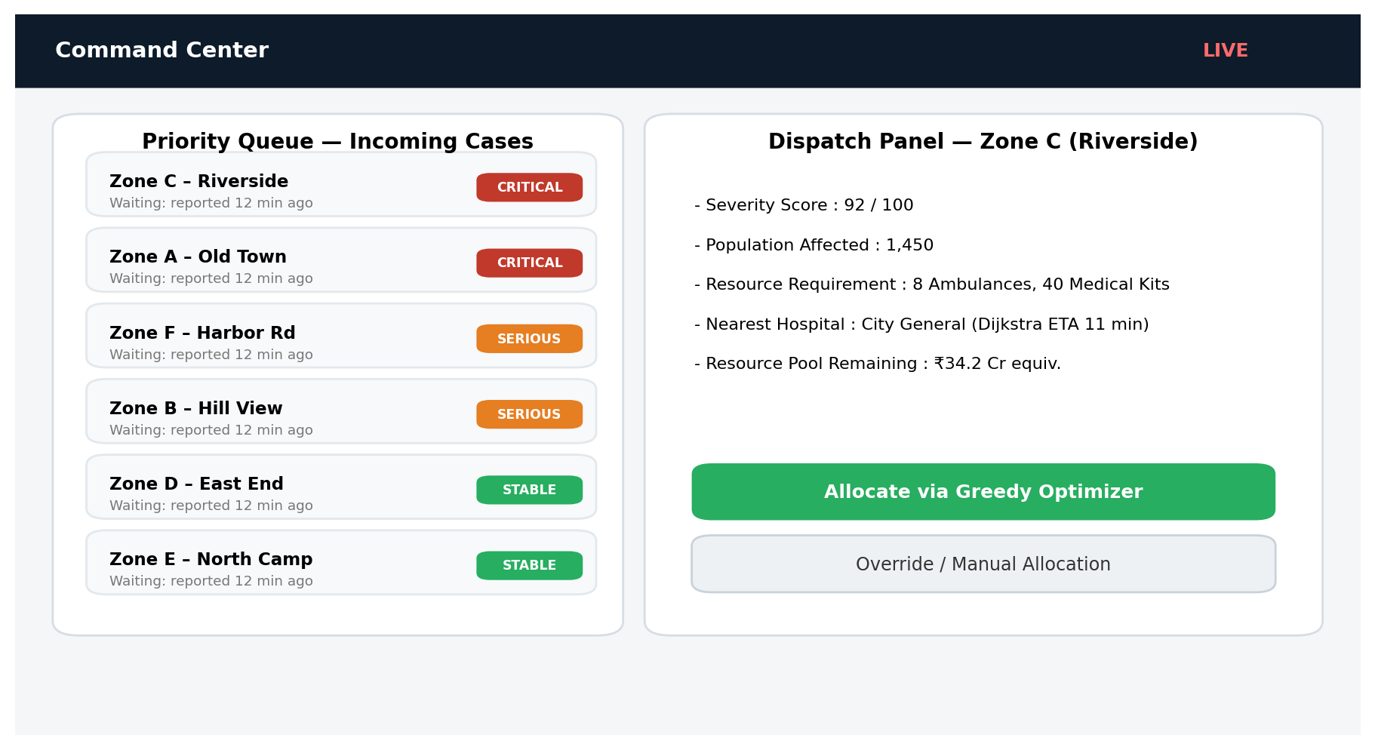
Figure 4.2 – Live Triage and Priority-Queue Dispatch
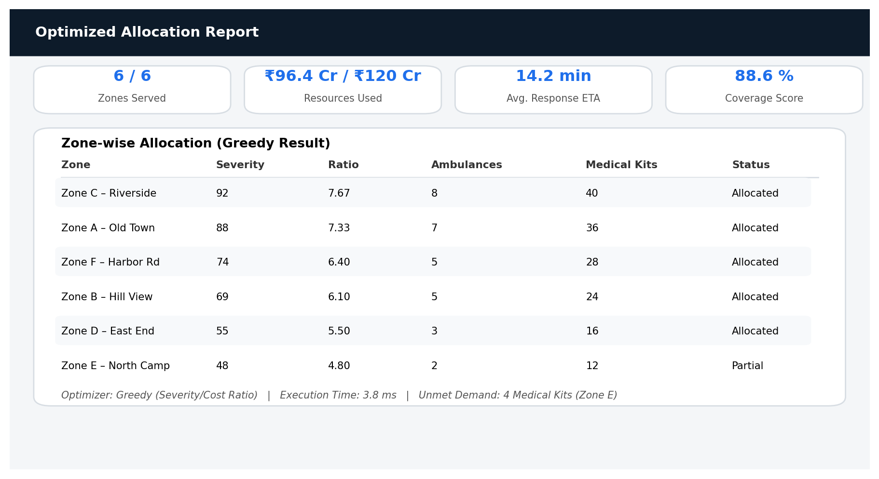

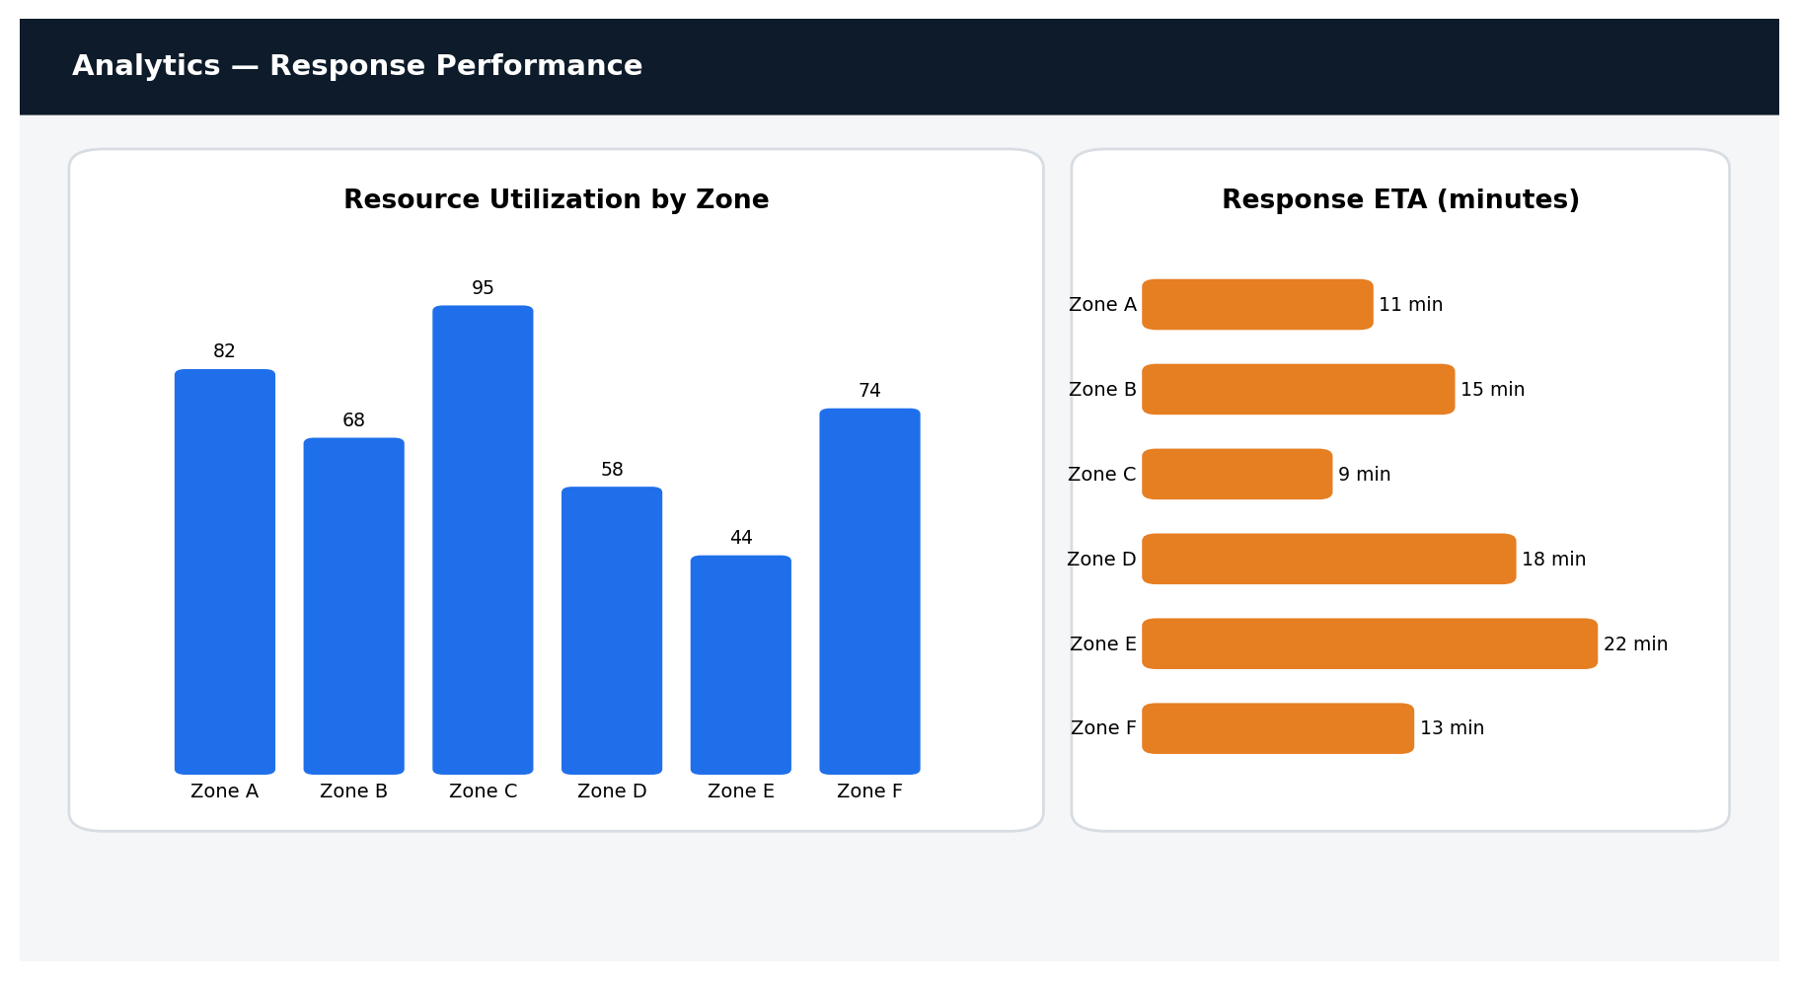

4.4 Results
The prototype demonstrates casualty and triage management, live priority-queue dispatch, resource-pool tracking, greedy allocation optimization, Dijkstra-based routing and analytics. Final execution times, objective values, allocation cost and screenshots should be inserted from the running build.

4.5 Data Analysis & Engineering Judgment
The optimization layer is separated from the interface so algorithm correctness and performance can be evaluated independently. The Greedy method provides a fast, easily re-computed allocation whenever new casualty reports arrive, which is essential during a live disaster response, while a DP/Knapsack benchmark can be run offline to check how close the greedy result is to the exact optimum for a given snapshot. For larger multi-objective formulations — balancing severity, equity across zones and response time together — more advanced optimization techniques may be considered.

4.6 Comparison with Existing Solutions & Achievement of Objectives

Objective | Evidence | Achievement
Implement greedy optimization | Greedy + Priority Queue + Dijkstra engine | Implemented / validate final build
Resource-pool-aware allocation | Constraint validation | Implemented / validate final build
Triage and dispatch management | Priority-queue and dispatch services | Implemented / validate final build
Analytics | Dashboard and charts | Implemented / validate final build
Testing | Algorithm and system test cases | Planned / validate final build

4.7 Strengths & Limitations

Strengths
➢ Fast, easily re-computed greedy allocation suited to rapidly changing disaster data.
➢ Clear three-module separation (triage, resource management, optimization).
➢ Demonstrates greedy-choice property, priority queues and shortest-path algorithms together.
➢ Transparent, explainable allocation ranking.
➢ Synthetic/simulation data supports privacy during testing.

Limitations
➢ Greedy allocation does not guarantee a global optimum in every scenario.
➢ Concurrent multi-user editing during a live mass-casualty event is only partially addressed.
➢ Advanced authentication and multi-agency integration are limited in the prototype.
➢ Depends on the accuracy and timeliness of field-reported severity data.

4.8 Project Planning, Roles & Budget

Milestone | Activity |  |  | Status
1 | Requirements and problem definition |  |  | Completed
2 | Literature and architecture |  |  | Completed
3 | Database and UI implementation |  |  | In progress
4 | Triage and dispatch engine integration |  |  | In progress
5 | Greedy optimization and routing implementation |  |  | In progress
6 | Testing, report and repository |  |  | Planned
Student |  | Assigned Responsibility | Actual Contribution
K. Sravan Kumar |  | Architecture, frontend, greedy engine and integration | To be updated

Item | Estimated Cost | Actual Cost
Existing laptop | Existing resource | Existing resource
Software / IDE | ₹0 | ₹0
MySQL / Flask / Bootstrap | ₹0 | ₹0
GitHub / version control | ₹0 basic use | ₹0
Dataset preparation | ₹0 / synthetic data | ₹0

CHAPTER 5

CONCLUSION, FUTURE WORK AND REFLECTION

5.1 Conclusion
The Disaster Healthcare Resource Allocation Using Greedy Algorithms system provides a structured decision-support solution for constrained, time-critical resource allocation during disasters. It combines casualty triage, hospital and resource management, resource-pool tracking and dispatch routing with DAA optimization techniques. The Greedy Algorithm identifies a high-priority resource allocation across affected zones within a defined resource pool, ranking zones by severity-to-cost ratio and allocating iteratively so that the plan can be recomputed within milliseconds as new casualty reports arrive. A Priority Queue (binary max-heap) supports live triage so that the most critical cases are always served first, and Dijkstra's shortest-path algorithm — a classical greedy technique — computes the fastest ambulance route to a hospital with available capacity. Overall, the project demonstrates how greedy algorithm design and analysis can be applied to a practical, life-critical humanitarian-logistics problem.

5.2 Future Work
➢ Extend the resource-pool model with a DP/Knapsack benchmark mode for offline comparison against the greedy result.
➢ Add authentication and role-based access control for multi-agency coordination.
➢ Integrate live GPS feeds from ambulances for real-time route re-optimization.
➢ Add automatic backup and restore for casualty and dispatch records.
➢ Add CSV/GIS import-export for zone and hospital-capacity data.
➢ Add cloud deployment and multi-user synchronization for command-center use during an active disaster.

5.3 Professional Learning & Individual Reflection

New Knowledge Acquired
➢ Greedy algorithm design, the greedy-choice property and when it does or does not guarantee optimality.
➢ Priority-queue (heap) implementation for live, dynamically changing triage data.
➢ Dijkstra's shortest-path algorithm applied to a real-world routing problem.
➢ Full-stack web application development connecting a Flask backend to a MySQL database.

Engineering & Professional Skills Developed
➢ Problem formulation and modular system design under real-world constraints.
➢ Debugging and functional testing of optimization logic.
➢ Git/GitHub version control.
➢ Technical documentation and presentation.
Individual Reflection: The most difficult engineering problem was keeping the allocation plan consistent while casualty severity data changed continuously as new field reports arrived. This was addressed by treating the resource pool and zone list as the persistent source of truth and re-running the greedy allocation whenever the underlying data changed, rather than trying to patch a stale plan incrementally. A key decision was to use a greedy algorithm rather than an exhaustive DP search as the primary engine, because the speed of re-computation matters more than guaranteed optimality when conditions change every few minutes during an active disaster response. If redesigned for production, stronger authentication, transactional consistency, and integration with real emergency-service data feeds would be added.

REFERENCES
[1] Cormen, T. H., Leiserson, C. E., Rivest, R. L., & Stein, C., Introduction to Algorithms.
[2] Kleinberg, J., & Tardos, É., Algorithm Design, Pearson.
[3] Dijkstra, E. W. (1959), "A Note on Two Problems in Connexion with Graphs," Numerische Mathematik.
[4] Sheu, J. B. (2007), "An Emergency Logistics Distribution Approach for Quick Response to Urgent Relief Demand in Disasters."
[5] Rawls, C. G., & Turnquist, M. A. (2010), "Pre-positioning of Emergency Supplies for Disaster Response."
[6] Wex, F., et al. (2014), "Emergency Response in Natural Disaster Management: Allocation and Scheduling of Rescue Units."
[7] Anaya-Arenas, A. M., et al. (2014), "Relief Distribution Networks: A Systematic Review."
[8] Ahmadi, M., et al. (2015), "A Multi-Depot Vehicle Routing Model for Post-Disaster Relief."
[9] Pallets Projects, Flask Documentation.
[10] Oracle, MySQL Documentation.
[11] Chart.js Documentation.
[12] MDN Web Docs, HTML, CSS and JavaScript Documentation.

APPENDICES

Appendix A – Detailed Calculations
No hardware sizing calculations are required for this software-based prototype. Record actual greedy-optimization execution time, memory usage where available, dataset size and final test results in the submission.

Appendix B – Engineering Drawings / Schematics
Step | System Flow
1 | User opens the application.
2 | User authenticates and selects the appropriate role.
3 | Zone, hospital and resource data are loaded.
4 | Casualty reports arrive and are pushed into the triage priority queue.
5 | Greedy allocation engine ranks zones and allocates resources within the pool.
6 | Dijkstra routing computes the dispatch route and ETA to the nearest available hospital.

Appendix C – Source Code / Code Repository Information
GitHub repository: Add the approved Disaster Healthcare Resource Allocation project repository URL before final submission. Complete source code may be maintained in the approved repository; include only essential excerpts in the report.

Appendix D – Dataset Information
The project dataset should contain disaster-simulation zone records including zone ID, location, casualty count, severity score, resource requirement and hospital-capacity records. Use a properly acknowledged public dataset or synthetic records for testing.

Appendix E – Experimental / Raw Data
Attach the final CSV/TXT dataset and selected test logs or screenshots here if required.

Appendix F – Ethics / Institutional Approval
No human-subject experiment is proposed. Casualty data should be sourced responsibly and acknowledged appropriately; synthetic records may be used for algorithm testing.

Appendix G – Project Meeting / Progress Records
Date | Activity | Outcome
21-07-2026 | Requirement discussion | Problem and scope finalized.
30-07-2026 | Architecture review | Four functional areas and greedy optimization approach selected.
20-08-2026 | Implementation review | Core application development reviewed.
25-08-2026 | Testing review | Algorithm and system test plan prepared.
07-09-2026 | Final review | Report and repository prepared.

Appendix H – Individual Contribution Evidence
K. Sravan Kumar (192311210) – primary contribution included architecture, greedy allocation and routing implementation, triage priority-queue logic, testing, documentation and repository preparation.

CAPSTONE PROJECT OUTCOME MAPPING SHEET
Outcome | Evidence | SO / Area | Location
Complex engineering problem formulation |  | SO1 | Chapter 1, Sections 1.2–1.3
Engineering design under constraints |  | SO2 | Chapter 3
Written/oral technical communication |  | SO3 | Whole report + Viva
Ethics and professional responsibility |  | SO4 | Chapter 3.7 / Appendix F
Teamwork and leadership |  | SO5 | Chapter 4.8 / Contribution Statement
Experimentation and engineering judgement |  | SO6 | Chapter 4.3–4.6
Independent knowledge acquisition |  | SO7 | Chapter 5.3
Standards |  | SO2 | Chapter 3.2
Sustainability / societal impact |  | SO2/SO4 | Chapter 3.7
Risk assessment |  | SO2/SO4 | Chapter 3.7
Security considerations |  | Relevant SO | Chapter 3.7
Integrated/system-level engineering |  | SO1/SO2 | Chapter 3.5
Project planning |  | SO5 | Chapter 4.8
Individual contribution |  | SO1–SO7 | Contribution + Chapter 4.8

